- Launch one EC2 using Amazon Linux 2 image and add a script in user data to install Apache.

1.Go to EC2 → Launch Instance.
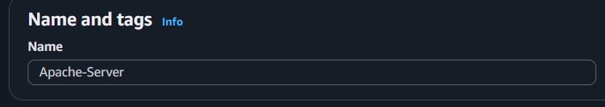
Enter the instance name (e.g., Apache-Server).
2.Under Application and OS Images (Amazon Machine Image):
Choose Amazon Linux.
Select Amazon Linux 2 AMI.
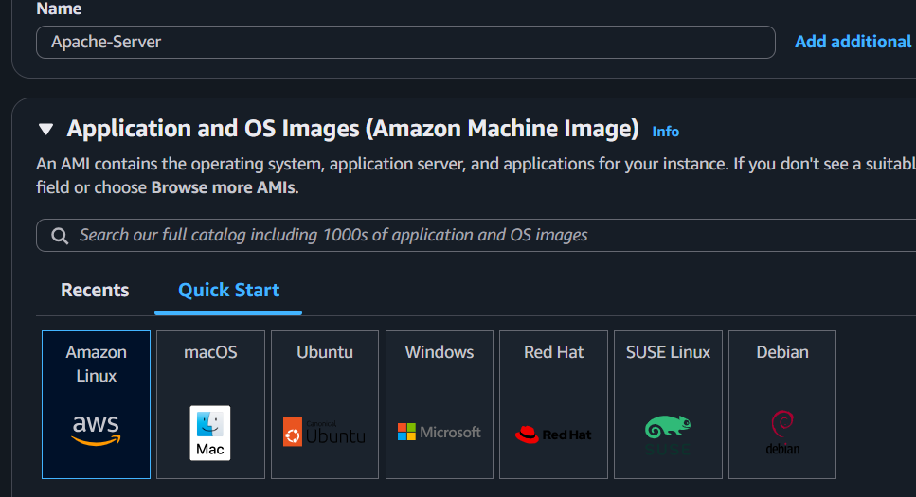
Choose t2.micro.
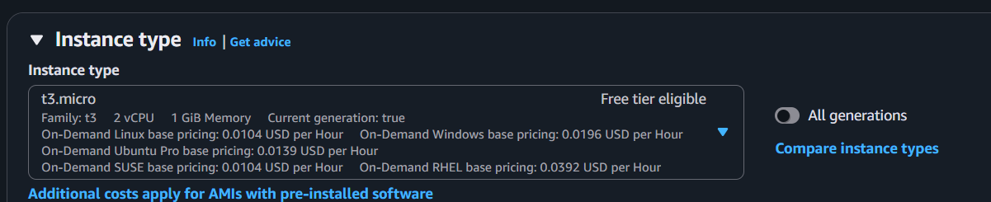

Select or create a key pair.
Allow SSH (22) and HTTP (80) in the security group.
Expand Advanced Details.
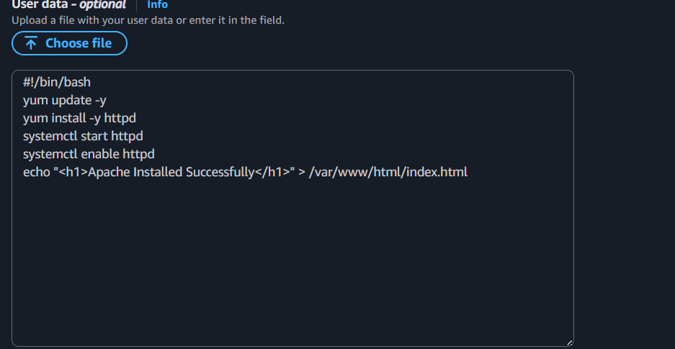
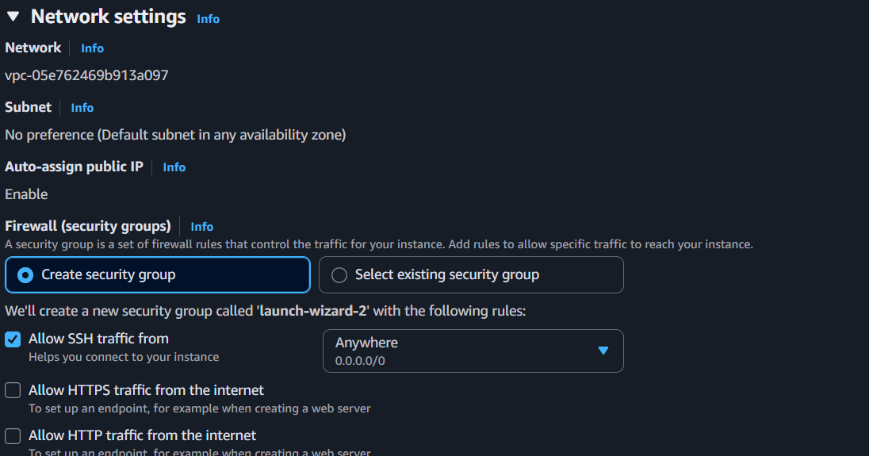
Paste the following into User data:

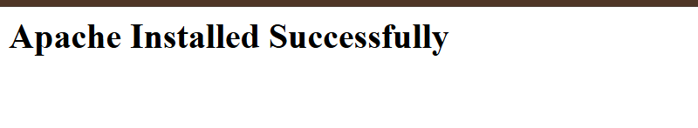

2.Launch one EC2 using Ubuntu image and add a script in user data to install Nginx.

Launch Ubuntu EC2 and Install Nginx using User Data
Step 1
Go to AWS Console → EC2 → Launch Instance
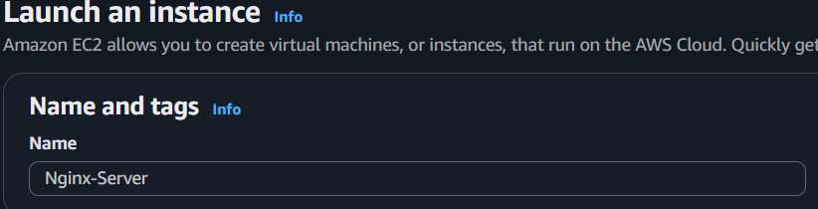
Name: Nginx-Server

Step 2
Under Application and OS Images (AMI):
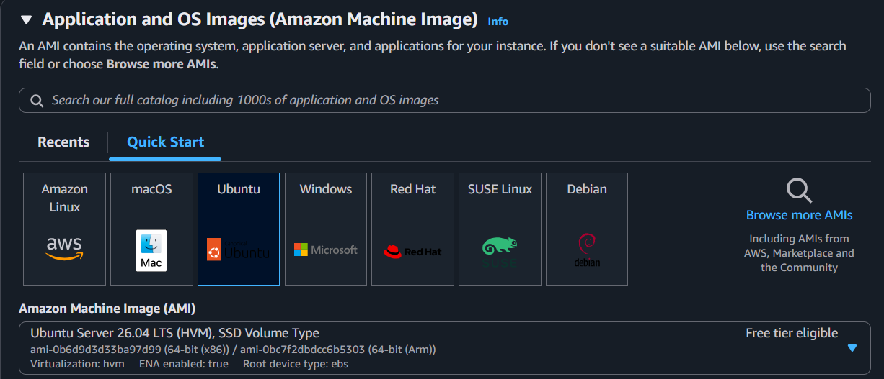
- Select Ubuntu Server (22.04 or 24.04 LTS)

Step 4
Instance Type: t3.micro
Select or create a Key Pair.
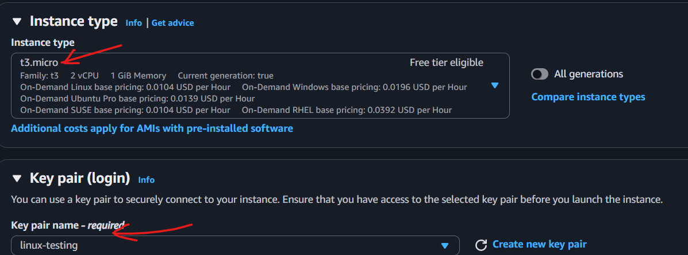
Step 5
Under Network Settings:
- Allow SSH (22)
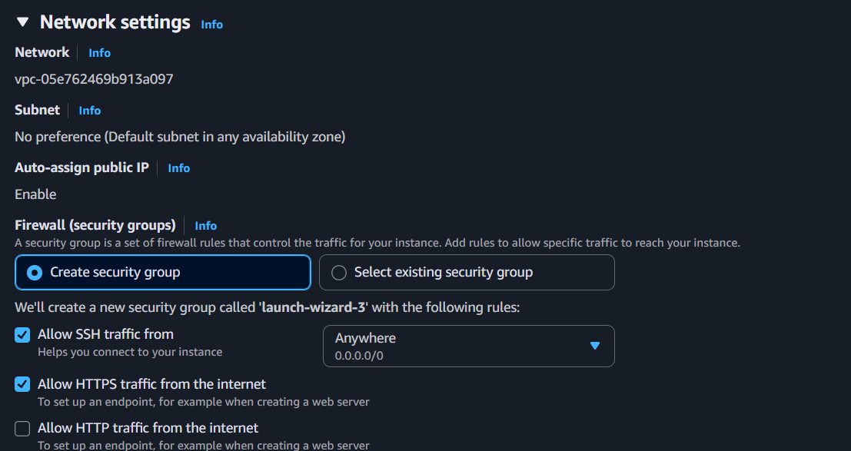
- Allow HTTP (80)

Step 7
Expand Advanced Details → User Data. 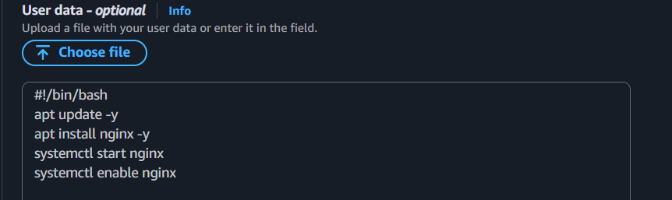
Step 8
Click Launch Instance. 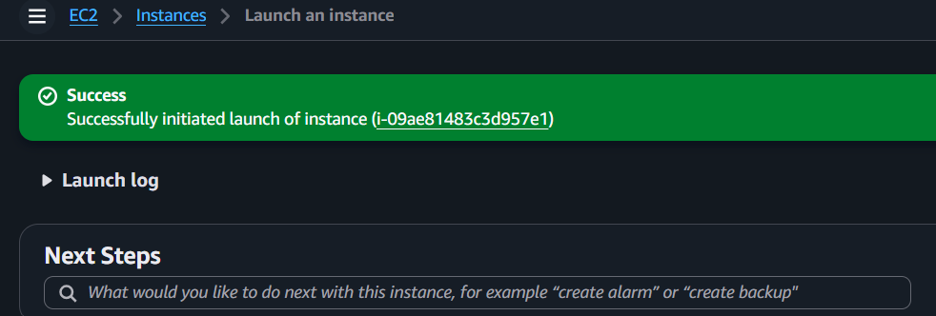
Step 9
Wait until the instance is Running and Status Checks Passed.
Step 10
Copy the Public IPv4 Address and open: 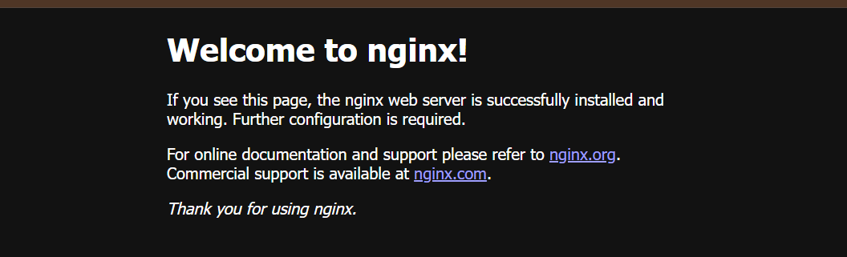

3. Launch one Windows server and install Tomcat on Windows.
Launch one Windows Server and Install Tomcat on Windows (Short Step-by-Step)
Step 1: Launch Windows EC2
- Go to AWS Console → EC2 → Launch Instance
- Name: Windows-Tomcat
- AMI: Windows Server 2025 Base (or latest Windows Server)

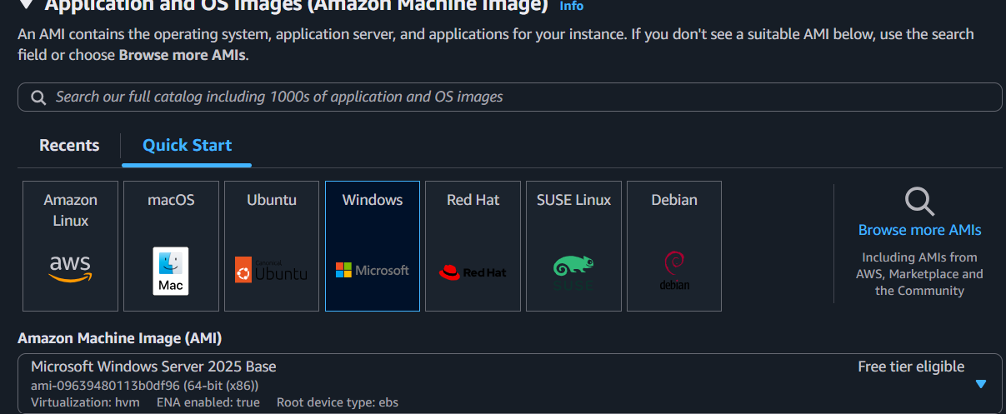
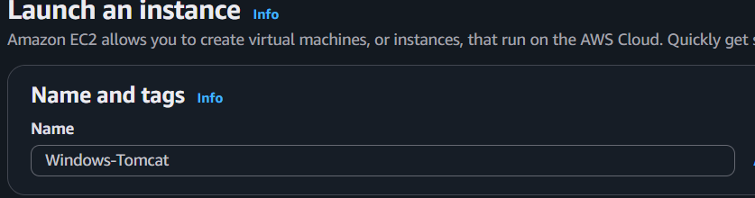
- Instance Type: t3.medium (recommended) or t3.medium
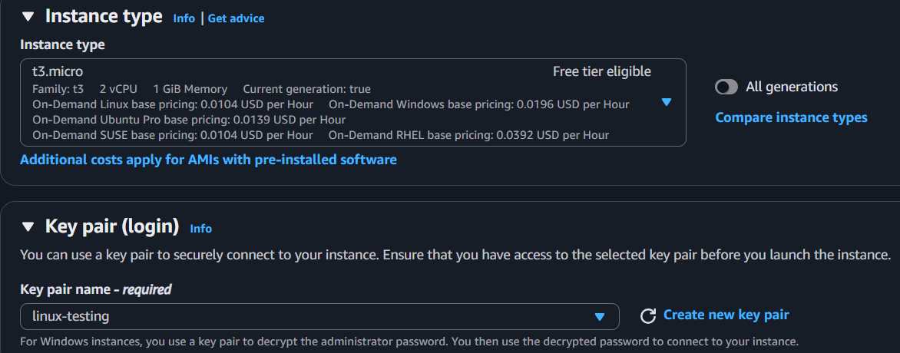
- Select a Key Pair.

Step 3: Network Settings
Allow these inbound rules:
- RDP (3389) → My IP

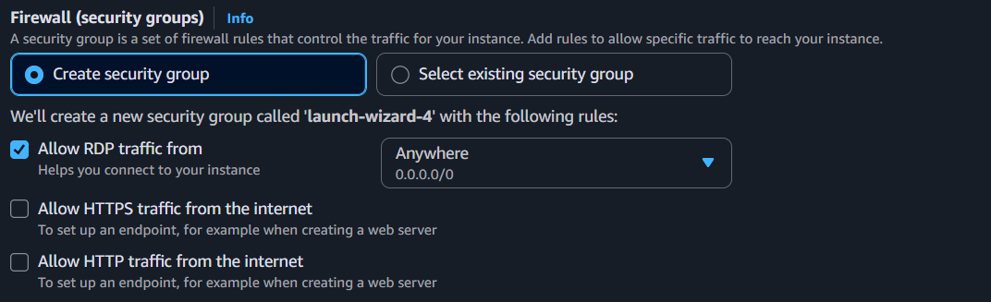
Step 4: Launch the Instance
Click Launch Instance. 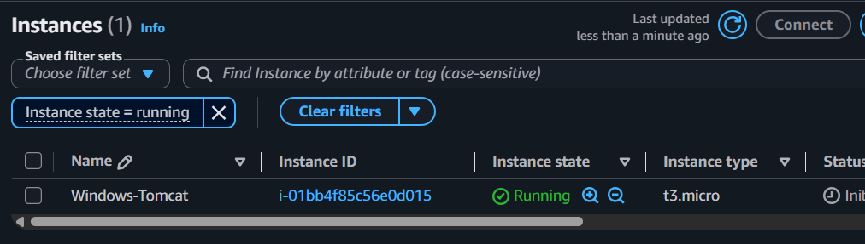
Step 5: Connect to Windows
- Select the instance.
- Click Connect → RDP Client.
- Click Get Password.
- Upload your .pem key.
- Decrypt the password.
- Download the RDP file and log in.
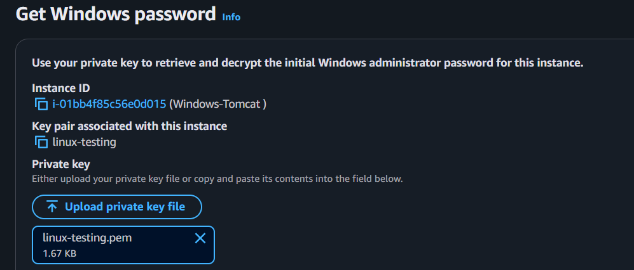
We need to connect to the Windows EC2 instance using RDP, open the Command Prompt (terminal), and then install Java and Tomcat.
Step 6: Install Java
- Download and install JDK 17 (or JDK 21).
- Set the JAVA_HOME environment variable.
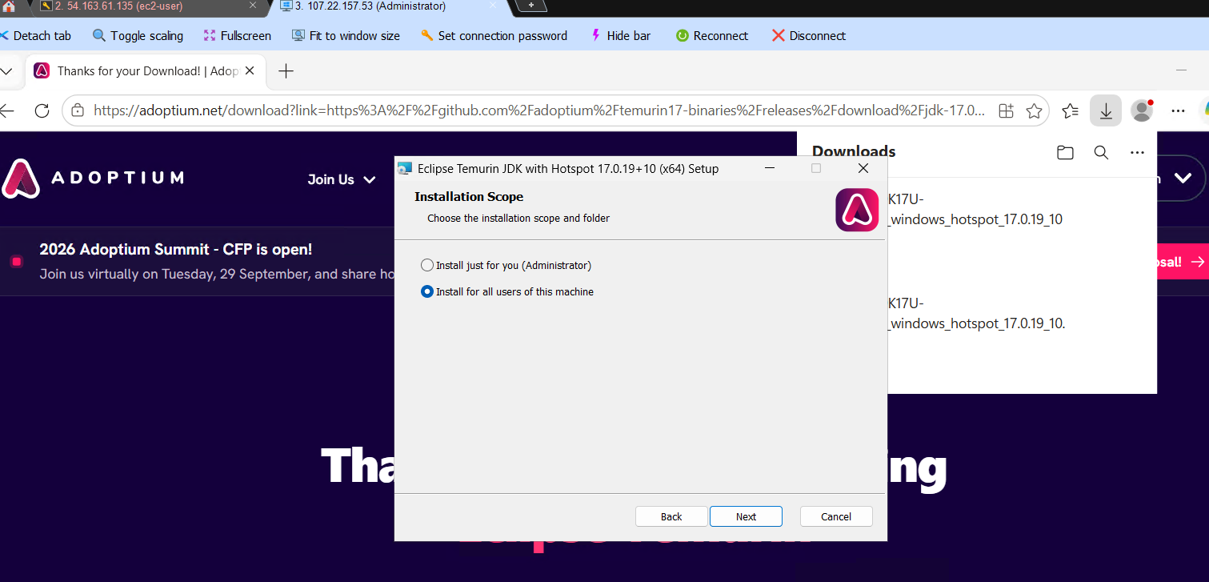
Step 7: Download Tomcat
Download Apache Tomcat 10 (ZIP version).
Step 8: Start Tomcat
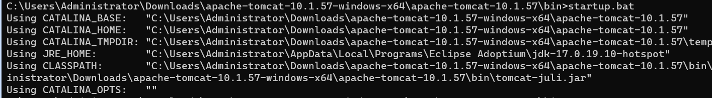startup.bat
Step 9: Verify Tomcat
Open a browser on the Windows server or your local machine:
http://localhost:8080
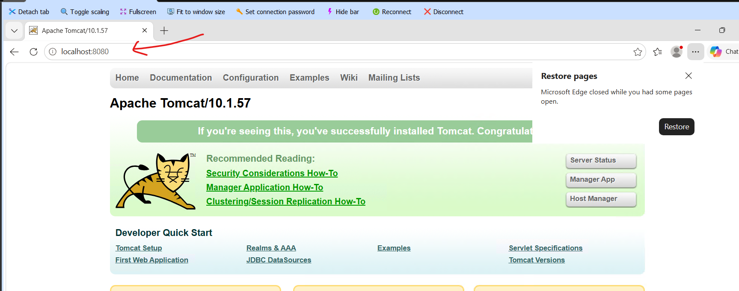

4.Take a snapshot of the instance created in Task 1.
Task: Take a Snapshot of the EC2 Instance
Log in to the AWS Console.
- Go to EC2.
- Click Instances.
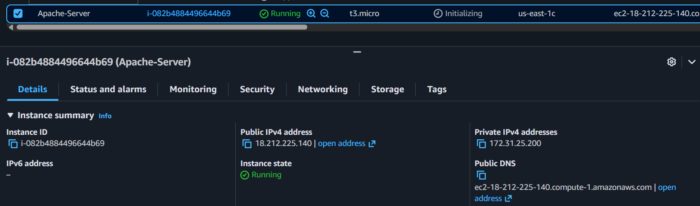
- Sel ect the EC2 instance created in Task 1.

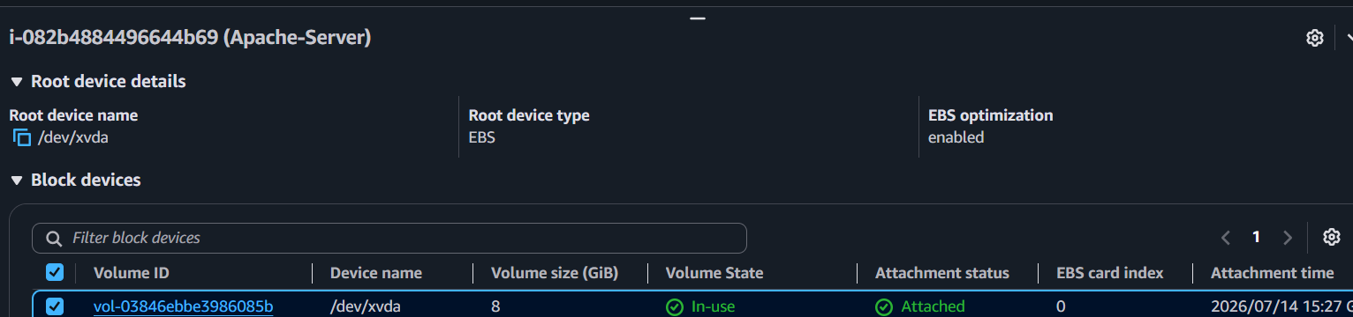
- Click Storage tab.

- Click the Volume ID attached to the instance.

- The Volumes page opens.
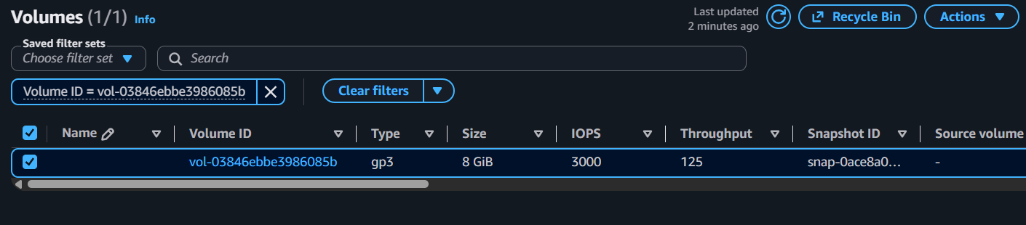
- Select the EBS volume.

- Click Actions → Create Snapshot.
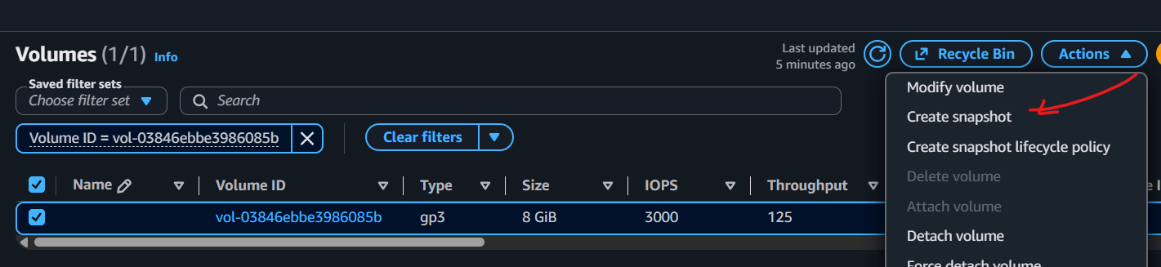
- Enter:
  - Name: Task1-Snapshot
  - Description: Snapshot of Task 1 EC2
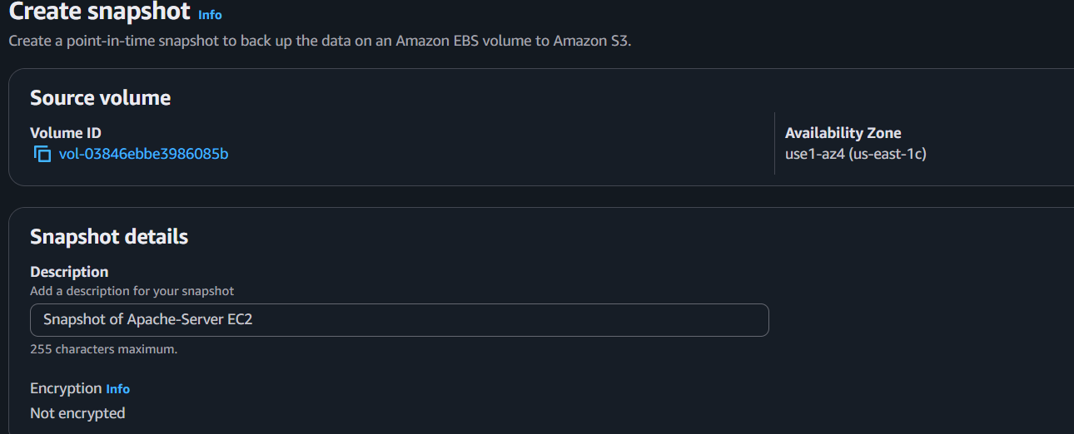
- Click Create Snapshot. 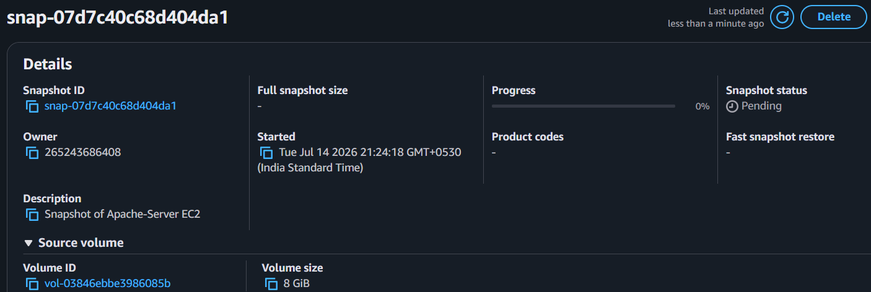
- Go to Elastic Block Store → Snapshots.
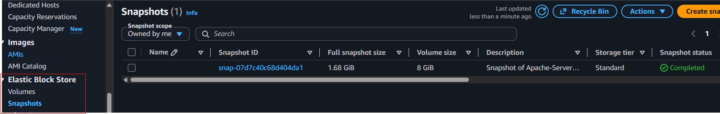
- Wait until the Status changes to Completed. ✅

5.Assign password less authentication for the EC2 created in Task 2.
Step 1: Create a new SSH key pair (on your local machine)
Run: ssh-keygen
Step 2: Display the public key
Run: cat /c/Users/sriva/.ssh/id_ed25519.pub

Step 3: Connect to the EC2 Instance Using the Private Key
Use the correct path to your .pem file.
ssh -i linux-testing.pem ubuntu@54.88.125.110
ssh-ed25519 AAAAC3NzaC1lZDI1NTE5AAAAIDZNws6SgaqFi6qQC+WGewdMjr/jUT+2qzAhmwnTXYX5 sriva@abhi
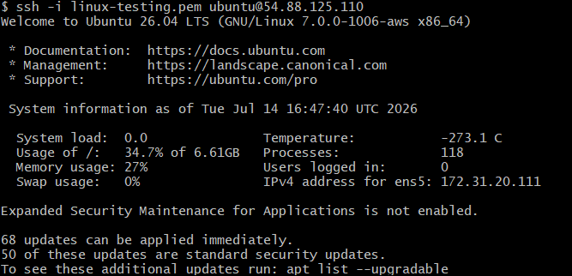
cd .ssh/
ls
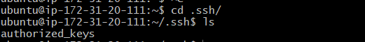

Step 4: Add the Public Key to authorized keys
Paste keygen : in editor –save
vi authorized_keys
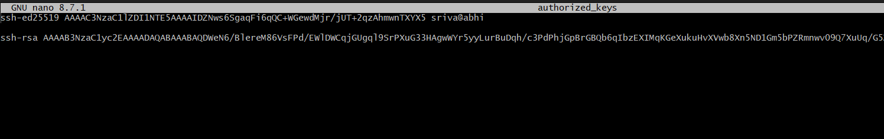
Step Name: Verify Passwordless Authentication
ssh ubuntu@54.88.125.110

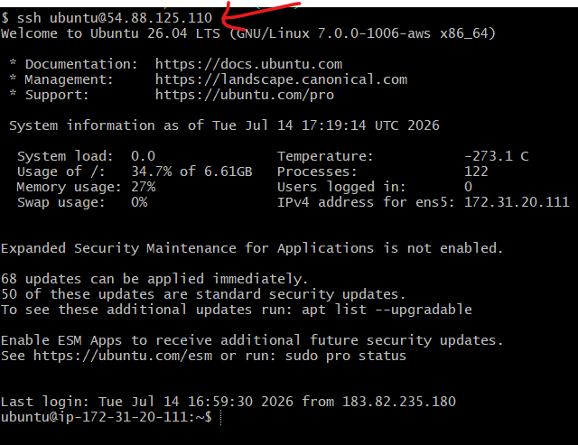

6.Launch any EC2 using the spot purchasing option.
Step 2: Start Launching an Instance
- Click Launch Instance.

Step 3: Enter Instance Details
- Name: spot-instance
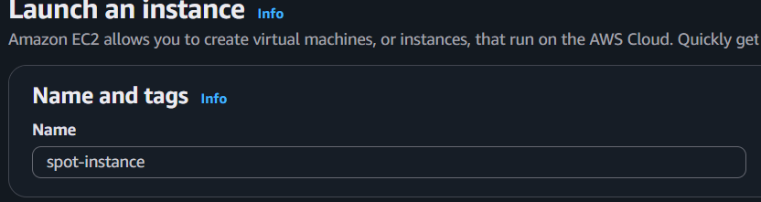
- AMI: Select Ubuntu or Amazon Linux
- Instance Type: t2.micro (or any available type)
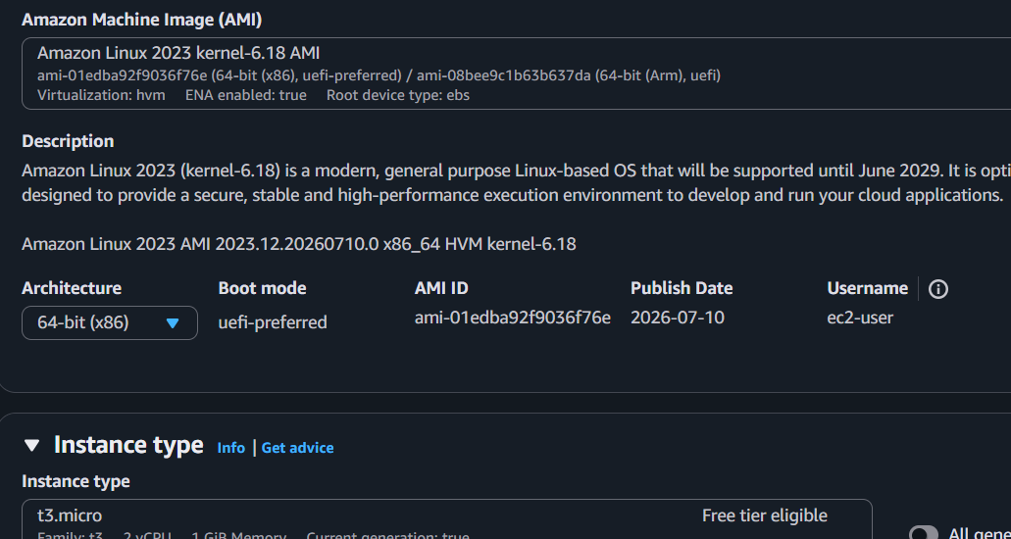

Step 4: Select the Spot Purchasing Option
- Scroll to the Purchase options section.
- Select Spot Instance.
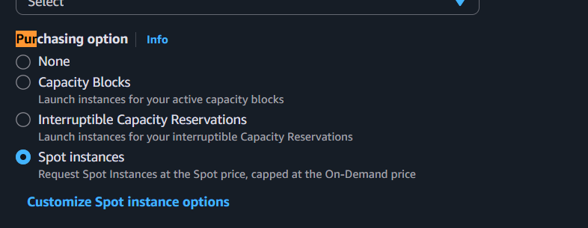

Step 5: Configure Spot Options
- Leave the default settings, or choose:
  - Request Type: One-time
  - Maximum Price: Leave blank (AWS uses the current Spot price)
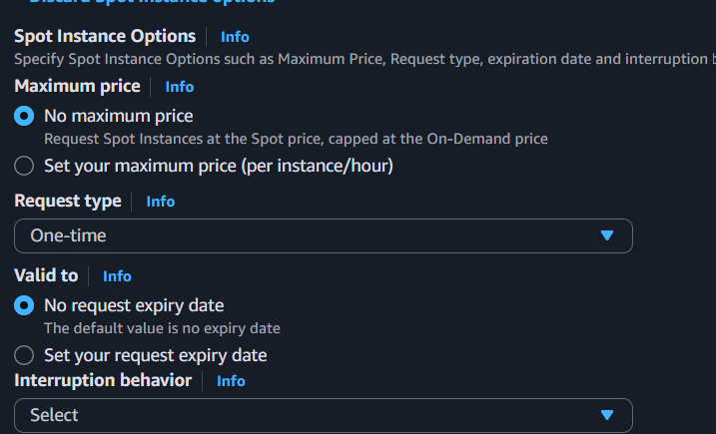

Step 6: Select a Key Pair
- Choose an existing key pair (for example, linux-testing) or create a new one.
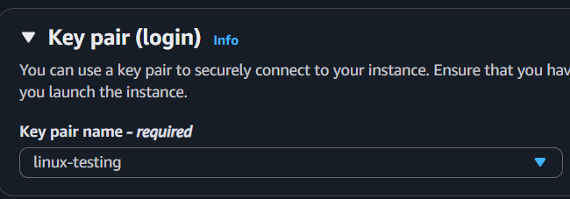

Step 7: Launch the Instance
- Click Launch Instance.
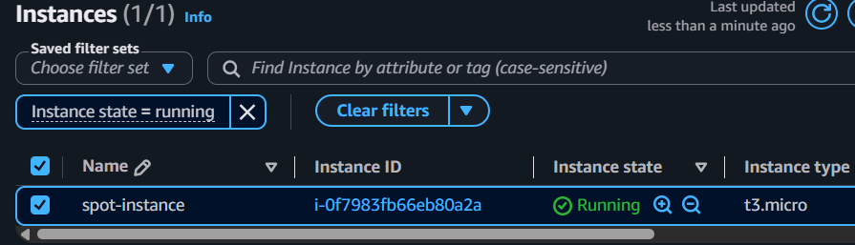
7.Enable termination policy on the EC2 created in Task 2.

Step 2: Select the EC2 Instance
- Select the EC2 instance created in Task 2. 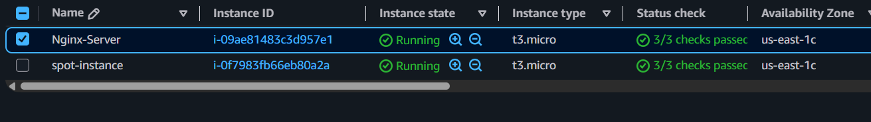

Step 3: Open Instance Settings
- Click Actions.
- Select Instance settings.
- Click Change termination protection. 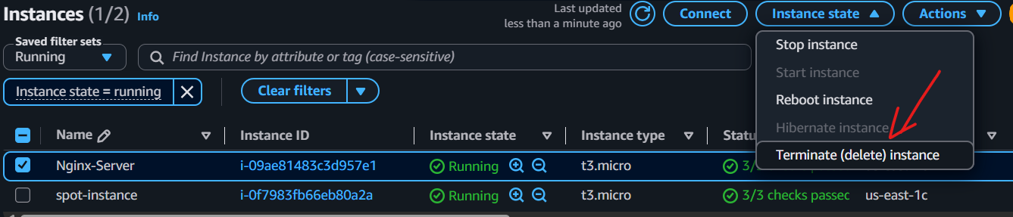

Step 4: Enable Termination Protection
- Check the box:
✔ Enable termination protection
- Click Save.
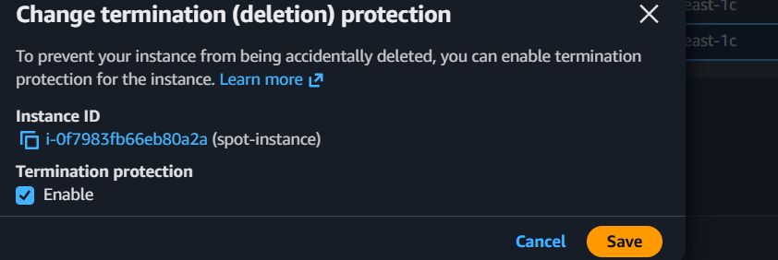
8.Launch one EC2 using AWS CLI.
Step 1: Open AWS CloudShell
- Log in to the AWS Console.
- Click the CloudShell ( >_ ) icon at the top-right.
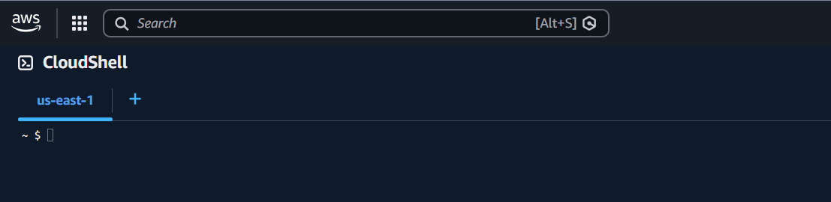

Step 2: Find the required values
Need these from your existing EC2 instance:
- AMI ID
- Key Pair Name
- Security Group ID
- Subnet ID
You can find them in EC2 → Instances → Select your instance → Details.
